**AMERICAN INTERNATIONAL UNIVERSITY–BANGLADESH (AIUB)**

**FACULTY OF ENGINEERING**

**DEPARTMENT OF COMPUTER ENGINEERING**

**DATA COMMUNICATION LABORATORY**

**Fall 2023-2024  
Section: I**

**Group: 4**

**EXPERIMENT NO: 6**

**Study of Digital to Analog Conversion using MATLAB**

|  |  |
| --- | --- |
| **Name** | **ID** |
| 1. MD. SHAHRIAR PARVEZ SHAMIM | 21-44998-2 |
| 2. MD. AL FAIAZ RAHMAN FAHIM | 21-45080-2 |
| 3. MD. OMAR FARUK SAKIB | 21-45077-2 |
| 4. MD. ABU HOJIFA | 21-45081-2 |
| 5. ASHFAT AHMAD MEDUL | 21-44854-2 |

**Submitted By:**

**Date of Submission**: **November 11, 2023**

**Abstract:**

In this experiment, we focused on utilizing MATLAB for solving communication engineering problems and developing an understanding of digital-to-analog conversion using MATLAB. The experiment involved designing a digital-to-analog converter using MATLAB and analyzing its performance. This provided us with a deeper understanding of the importance of digital-to-analog conversion in communication systems and how to implement it using MATLAB.

**Theory:**

**DIGITAL TO ANALOG CONVERSION:** Digital to analog conversion is the process of changing one of the characteristics of an analog signal based on the information in digital data Figure bellow shows the relationship between the digital information, the digital to analog modulating process, and the resultant analog signal.

**ASK:** In amplitude shift keying, the amplitude of the carrier signal is varied to create signal elements Both frequency and phase remain constant while the amplitude changes.

**FSK:** In frequency shift keying, the frequency of the carrier signal is varied to represent data The frequency of the modulated signal is constant for the duration of one signal element, but changes for the next signal element if the data element changes Both peak amplitude and phase remain constant for all signal elements.

**PSK:** In phase shift keying, the phase of the carrier is varied to represent two or more different signal elements Both peak amplitude and frequency remain constant as the phase changes Today, PSK is more common than ASK or FSK. However, we will see shortly that QAM, which combines ASK and PSK, is the dominant method of digital to analog modulation.

**Results:**

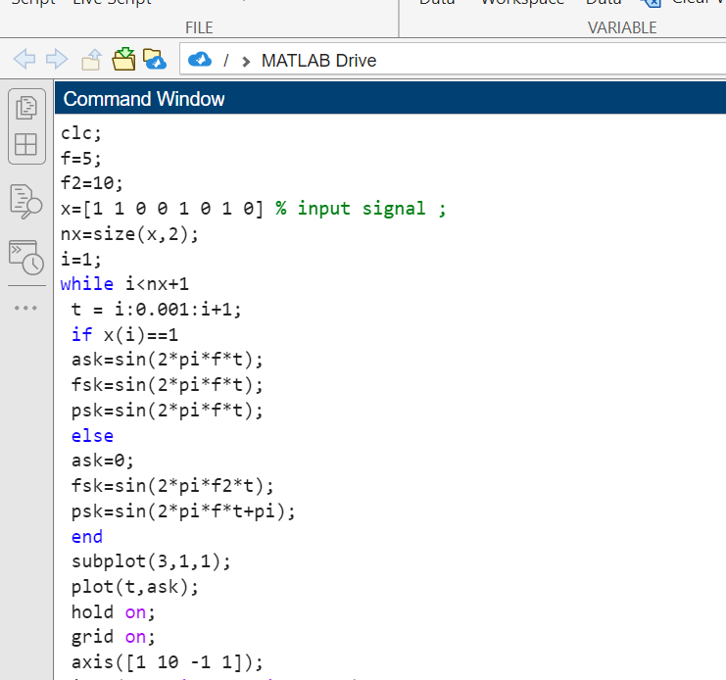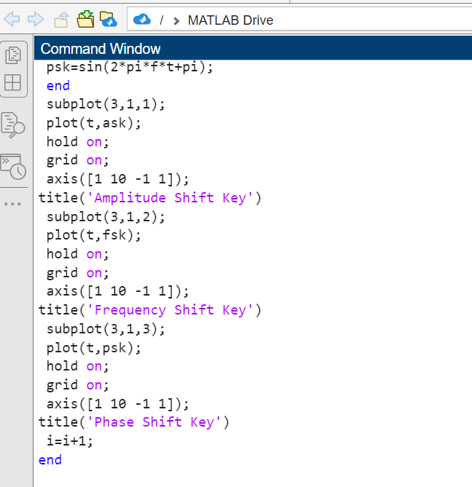

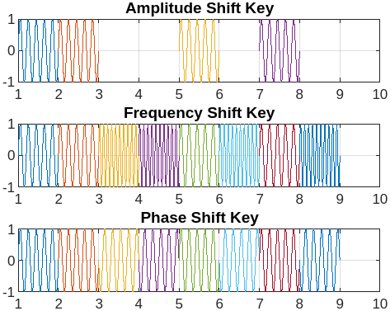

Figure 1: ASK, FSK and PSK

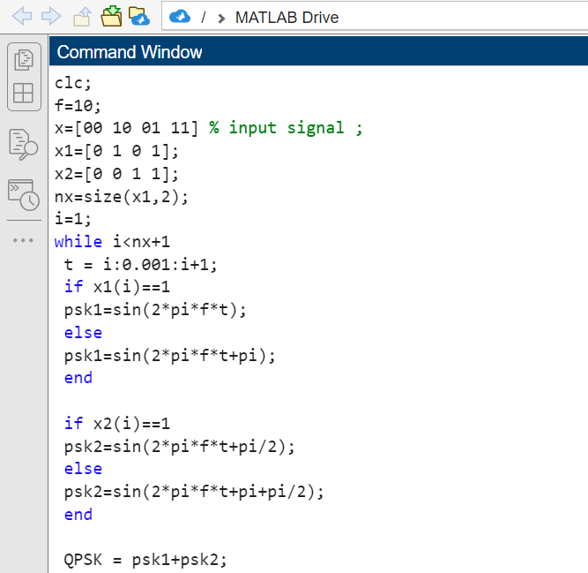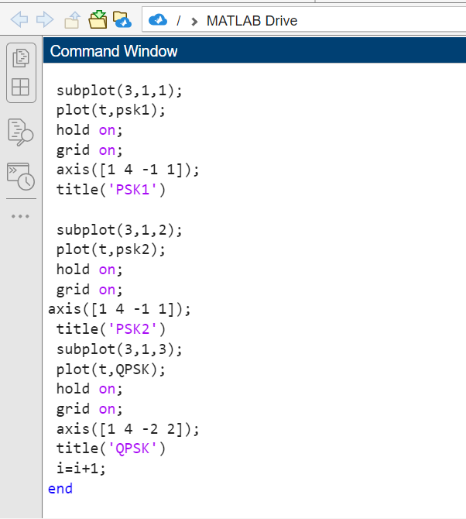

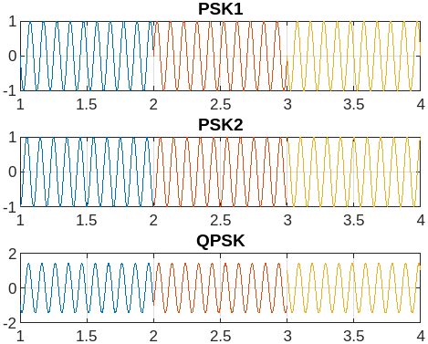

Figure 2: QPSK

|  |  |  |
| --- | --- | --- |
| **ID =** AB-CDEFG-H  **ID =** 21-45077-2 | E=0  F=7  G=7 | Bit Stream = 000001110000100100000011 |

**Performance Task:**

1.

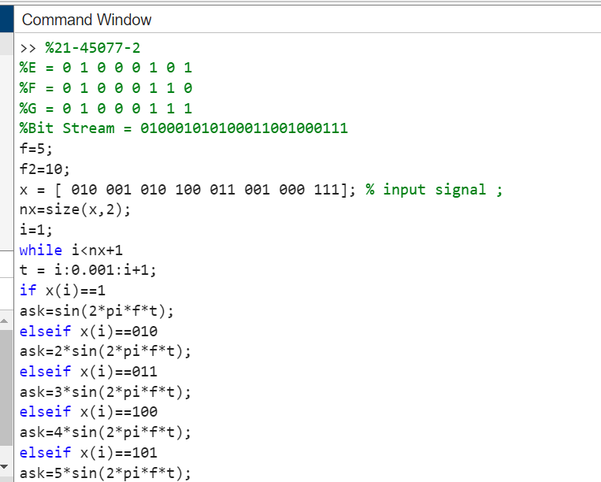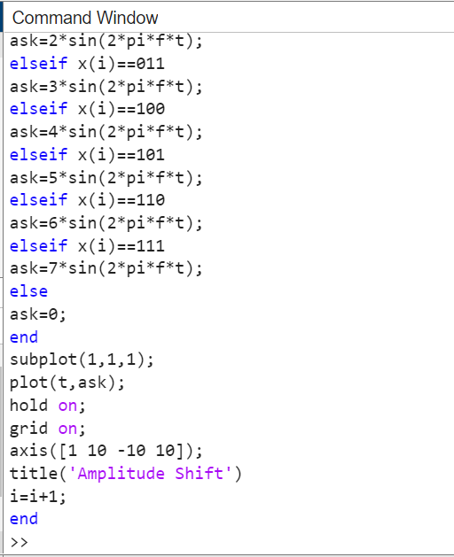

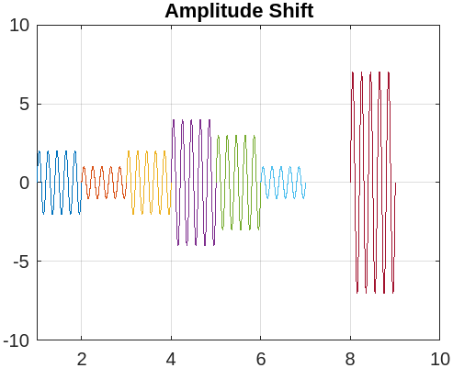

Figure 1: Performance Task 01(Amplitude Shift)

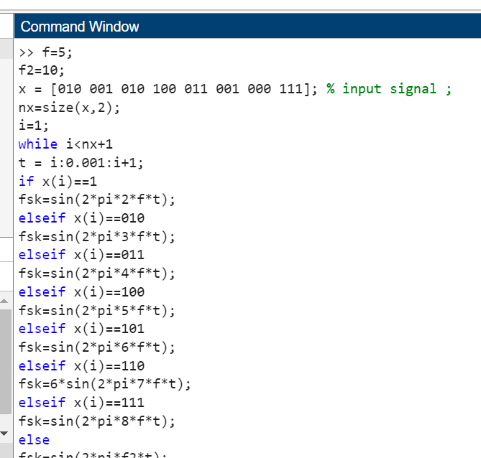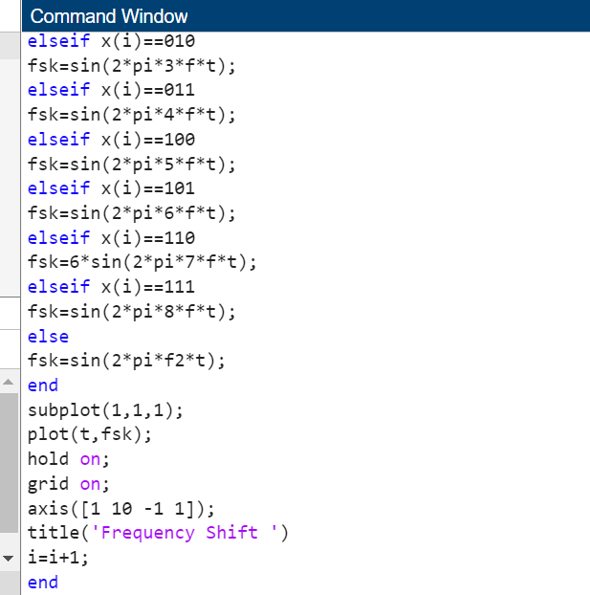

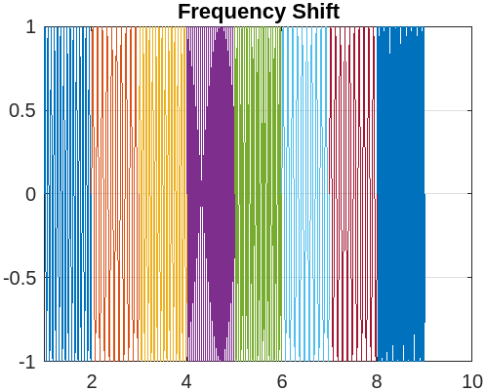

Figure 2: Performance Task 02 (Frequency Shift)

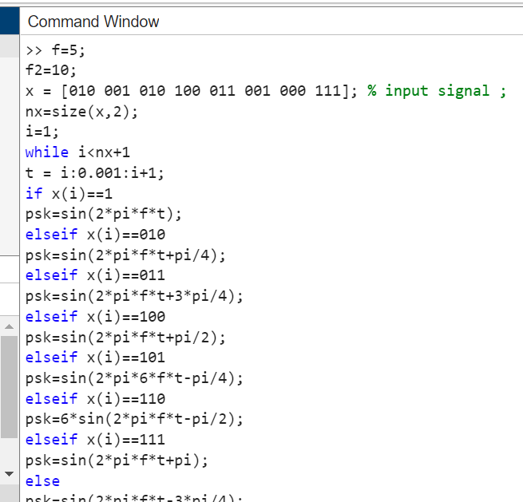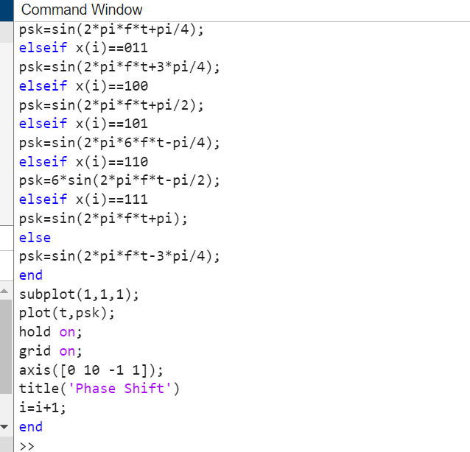

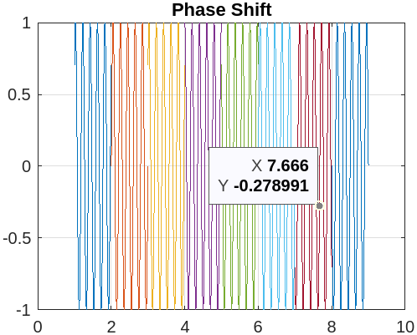

Figure 3: Performance Task 03(Phase Shift)

**Discussion & Conclusion:** In this lab experiment, we explored the process of digital-to-analog conversion using MATLAB. We performed digital to analog modulation using different modulation techniques such as Amplitude Shift Keying (ASK), Frequency Shift Keying (FSK), and Phase Shift Keying (PSK). In ASK modulation, we modulated a digital signal onto an analog carrier signal by varying the amplitude of the carrier signal. In FSK modulation, we modulated a digital signal onto an analog carrier signal by varying the frequency of the carrier signal. In PSK modulation, we modulated a digital signal onto an analog carrier signal by varying the phase of the carrier signal. We also explored Quadrature Phase Shift Keying (QPSK), which is a more advanced modulation technique used in modern communication systems. We wrote MATLAB code to generate digital signals, modulate them using different modulation techniques, and then convert them back to analog signals. We then plotted the results to visualize the modulation and demodulation processes.

**References:**

**[1]** W. Stallings, Data and computer communications. 2000., Accessed: Nov.11 , 2023. [Online].

Available:<https://www.portcity.edu.bd/files/636444710465881602_Dataandcomputercommunications.pdf> [Online Copy]

**[2]** B. A. Forouzan, C. A. Coombs, and S. C. Fegan, Introduction to data communications and networking. McGraw-Hill Science, Engineering & Mathematics, 1998., Accessed: Nov.11, 2023. [Online]. Available: <https://archive.mu.ac.in/myweb_test/syllFybscit/dcn.pdf> [Online Copy]